Data Analytics Corporate training program

Name - Neelima Rani

Batch Name -Data Analytics with PowerBi ,Sql,Tableau.

[E-mail : ranineelima208@gmail.com](mailto:Email-ranineelima208@gmail.com)

# Sql Project

Dataset: E-Commerce

Data Link is -[C:\Users\neeli\OneDrive\Desktop\sql prjt.zip](C:\\Users\\neeli\\OneDrive\\Desktop\\sql prjt.zip)

**1)Total Sales:Calculate the total Sales**

select * from details

select * from orders

select sum(Amount) as Total_Sales from details;

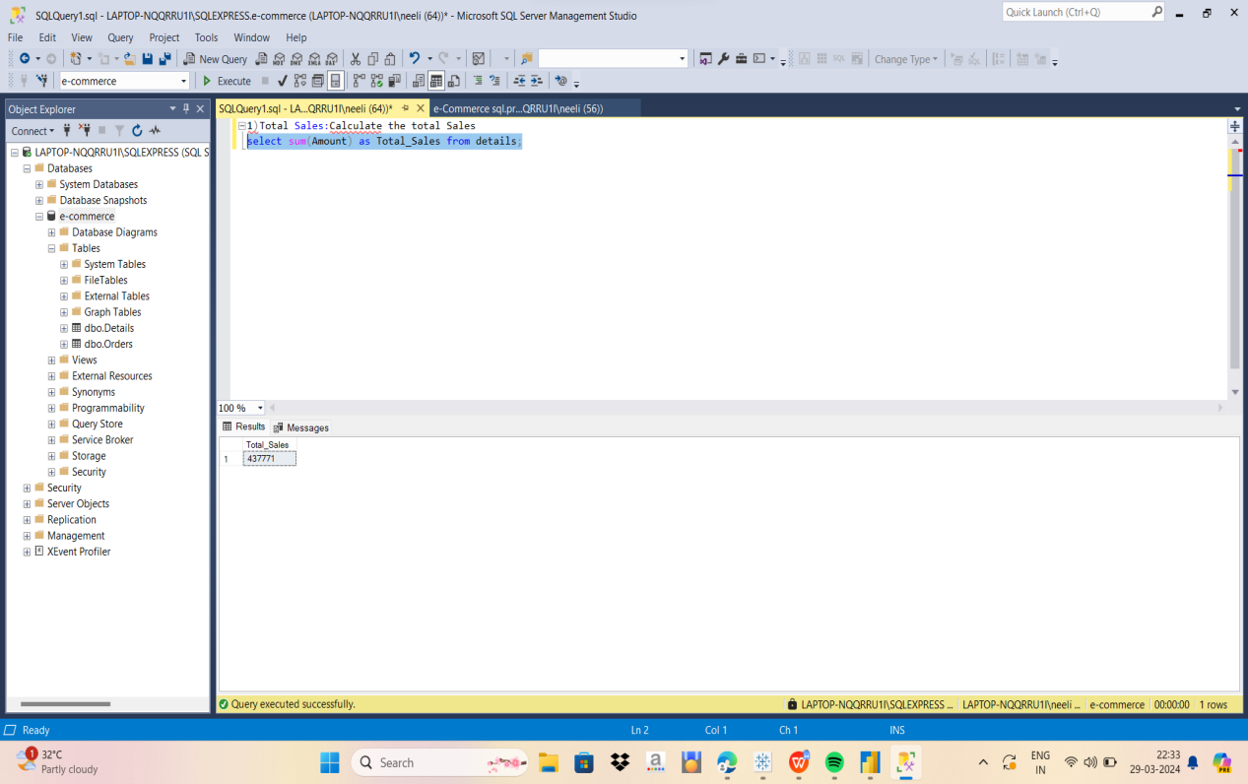

**--2) Total Profit:Calculate the total Profit**

select sum(profit) as total_profit from details;

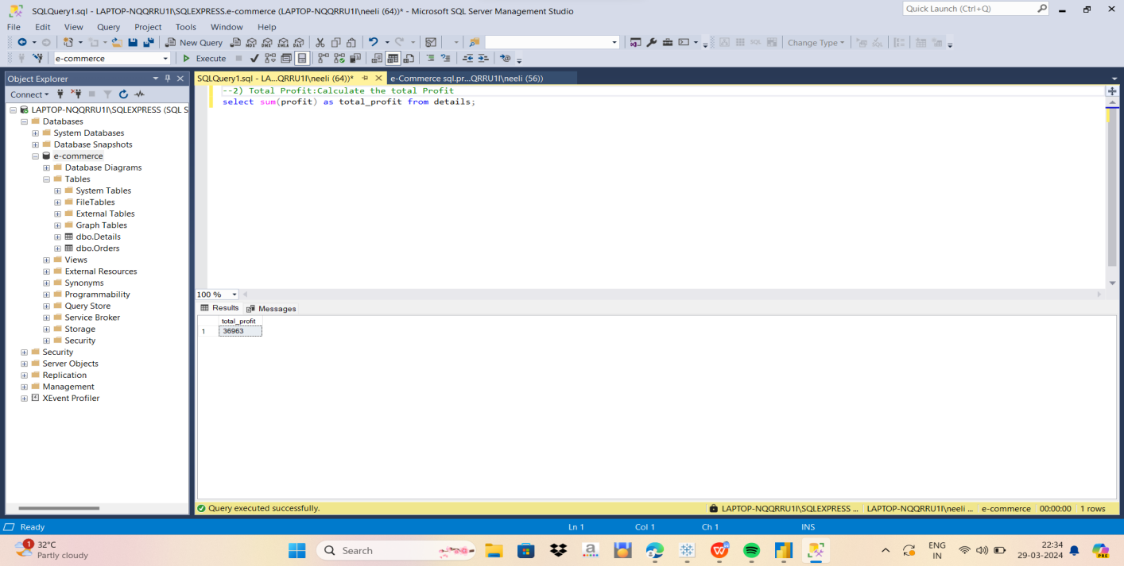

**--3)Total Quantity:Calculate the total Quantity**

select sum(Quantity) as total_profit from details;

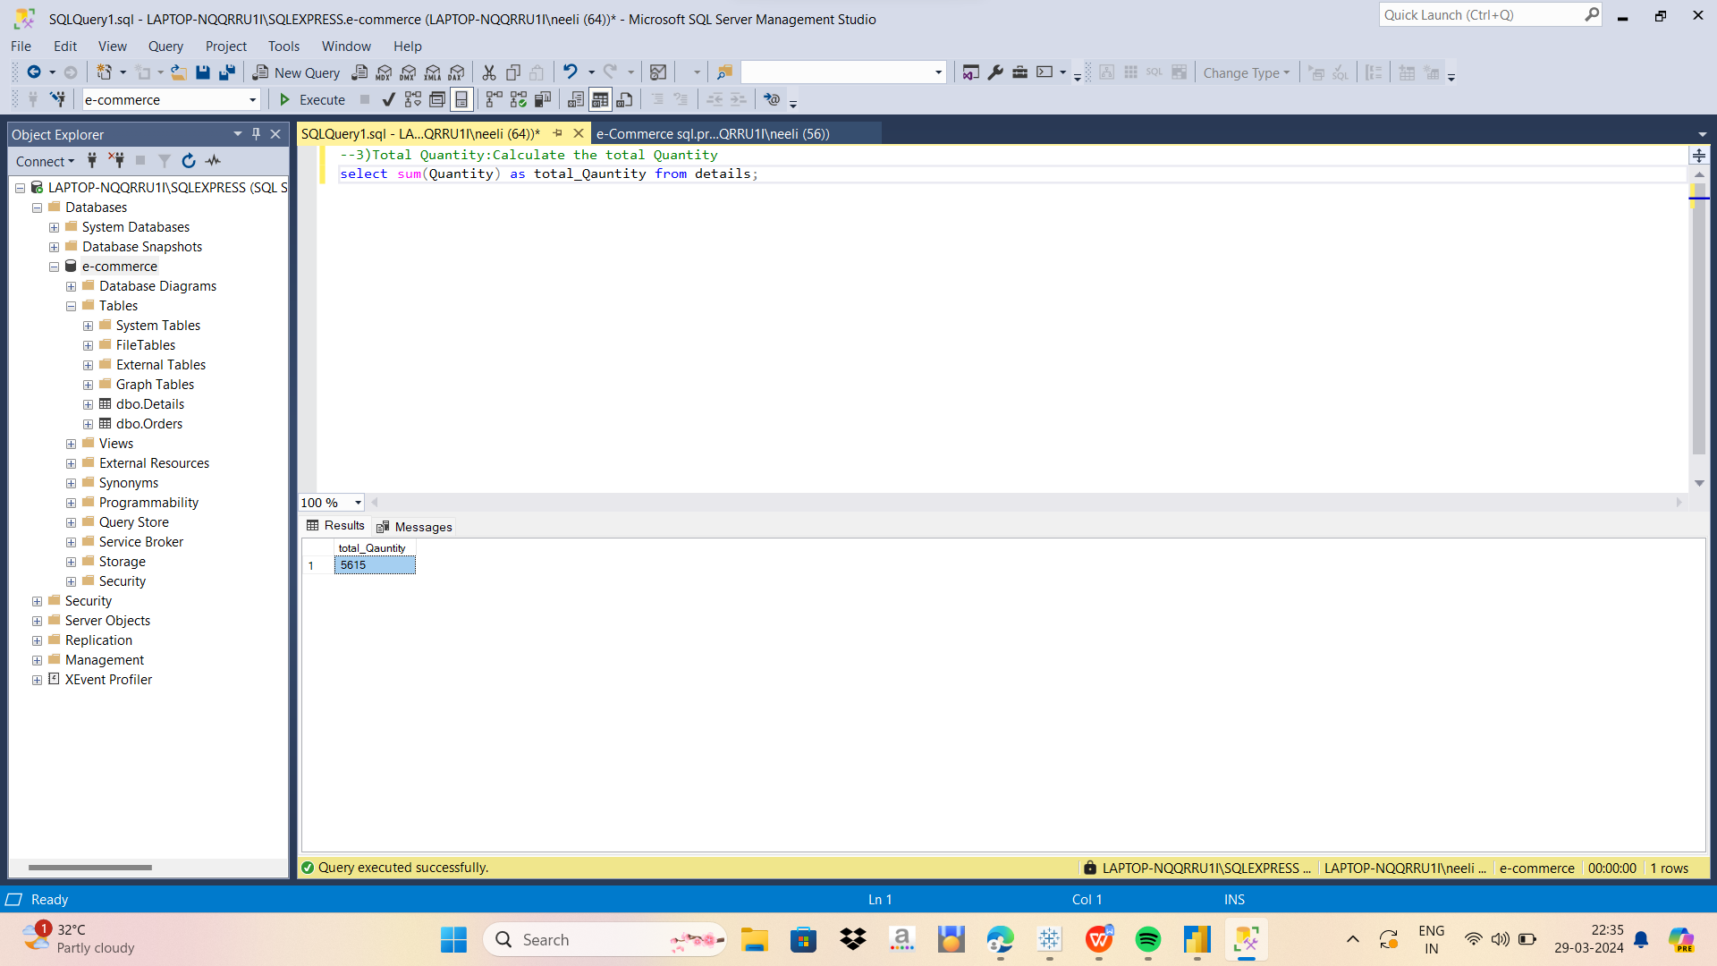

**--4)Total Sales By Category:Calculate The Total Sales by Category**

select Category,sum(amount) as Total_sales from details group by Category;

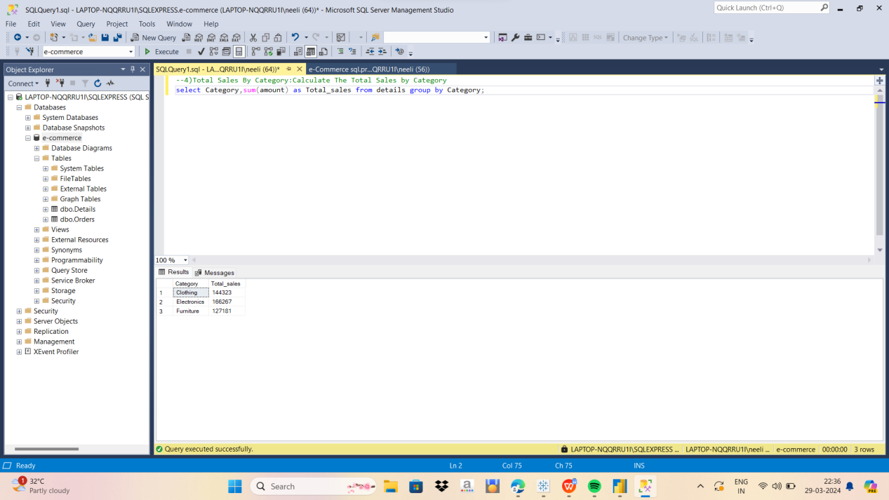

**--5)Top 5 Customers Name By Total Sales: Calculate Top 5 Customer Name By total Sales**

Select top 5 orders.CustomerName,sum(details.amount)as total_sales from orders inner join details on orders.order_id=details.order_id group by orders.CustomerName order by total_Sales desc;

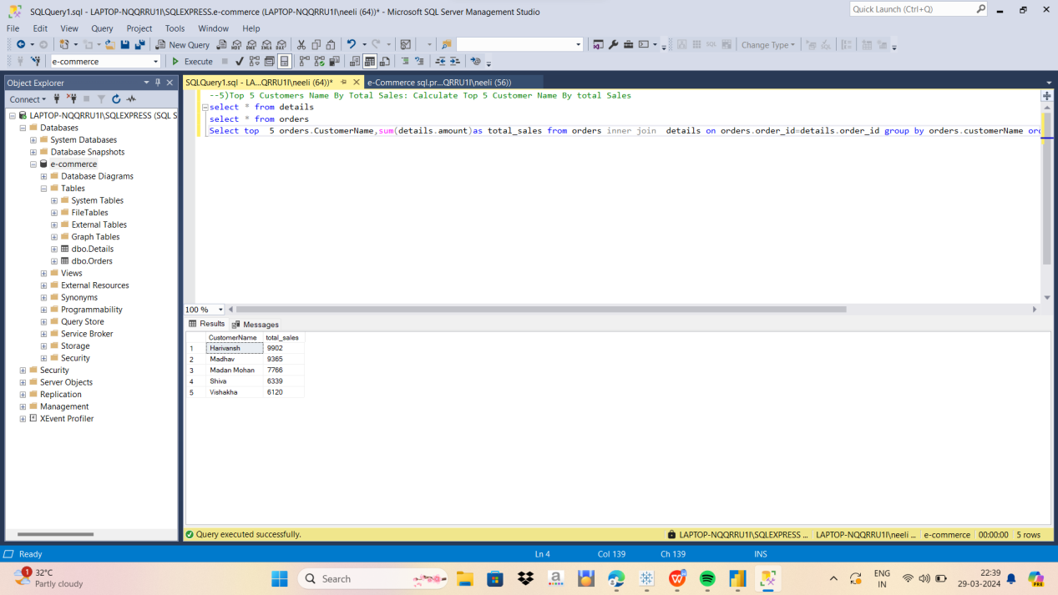

**--6)Total Sales By Payment Mode:calculate the Total Sales by Payment Mode**

select Paymentmode,sum(amount) as Total_sales_by_Paymentmode from details Group by Paymentmode;

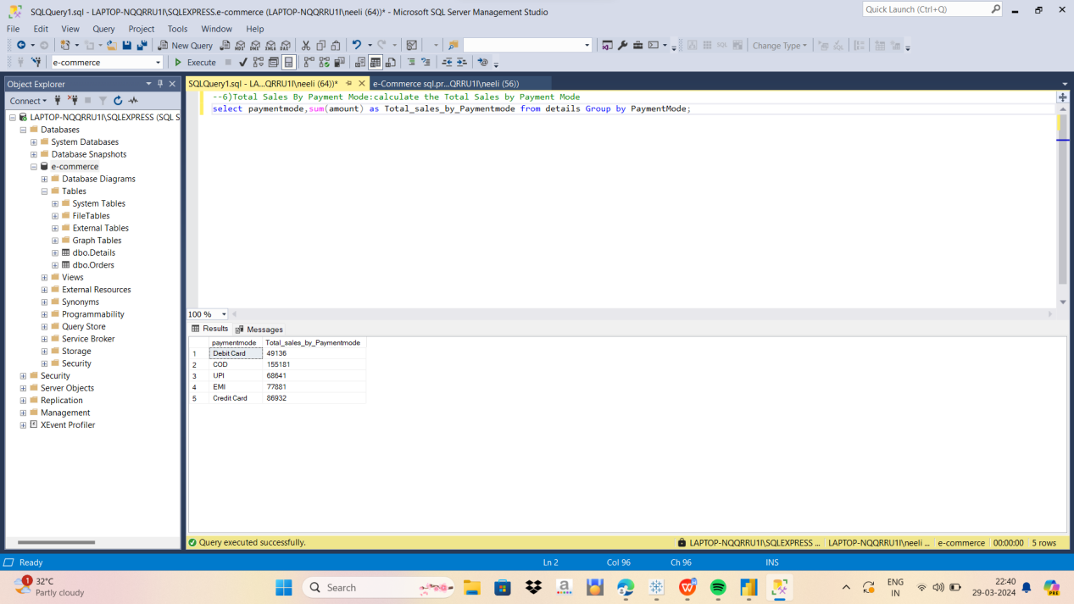

**--7)Total Sales by Subcategory:Calculate the Total Sales By SubCategory**

select sub_category ,sum(amount) as total_Sales from details group by sub_Category order by total_sales desc;

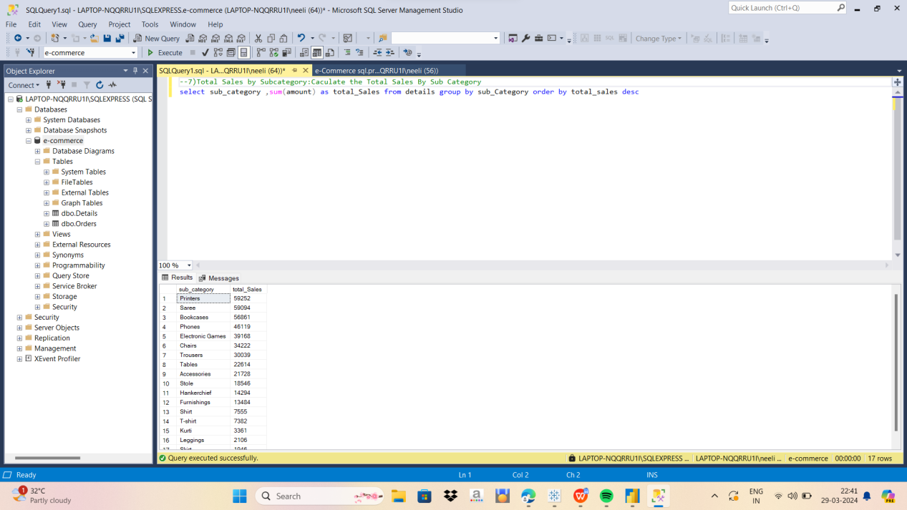

**--8)Top 5 Sales By State By Total Sales:calculate the top 5 State By Total Sales**

select top 5 orders.state,sum(details.amount) as Total_sales From Orders inner join details on orders.order_id=details.order_id group by orders.state;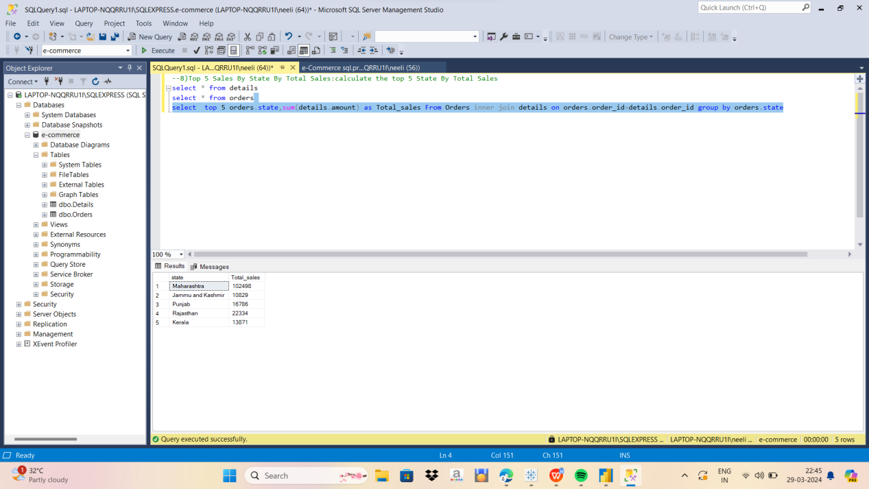

**--9) Top 5 City by Total sales by total profit:Calculate Top 5 City by Total Sales by Profit**

Select Top 5 orders.city,sum(details.amount) as Total_Sales,Sum(Details.profit) as Total_Profit from orders inner join details on orders.order_id=details.order_id group by orders.city order by total_sales,Total_profit desc;

